Dayton Flores

Joseph Sharp-Halpin

Dr. Venkatesan Muthukumar

CpE 403 - 1001

10 Dec 2018

Cpe 403 Final Project

Problem Statement:

*The goal was to setup a remote system for embedded application development to collect temperature and lux data. This was accomplished by interfacing sensors with a CC1350 board to collect temperature and lux data, and sending the data via RF to a second CC1350 board (CoProcessor) which sent the data to the BBB. The BBB then uploads to the TI-15.4 Stack Collector App.*

Circuit to create:

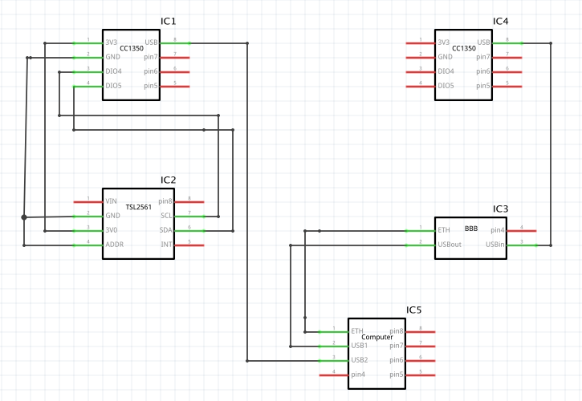

pre-requisites:

* CCS 7.2 (Code Composer Studio)
  + <http://www.ti.com/lit/ug/slau157ap/slau157ap.pdf>
* TI-15.4 Stack Example Application
  + <https://unlv.instructure.com/courses/5342/files/4949433/download?verifier=CJWkj6ZZF5GmKzPhujWqDWnywhxJSQbOksHMOwmS&wrap=1>
* Arago Project
  + <http://arago-project.org>
* Uniflash
  + <http://www.ti.com/tool/UNIFLASH>
* Sensor + CoProcessor Firmware (CC1350)

implementation details:

Steps used in design:

* 1. Flash CC1350 Sensor + CC1350 CoProcessor
  2. Setup Beaglebone Board with Arago Project
  3. Wire lux sensor to CC1350 Sensor
  4. Activate Collector App on browser
  5. Debug and run program through CCS 7.2
  6. Connect Sensor + CoProcessor through RF
  7. Observe values in Collector App

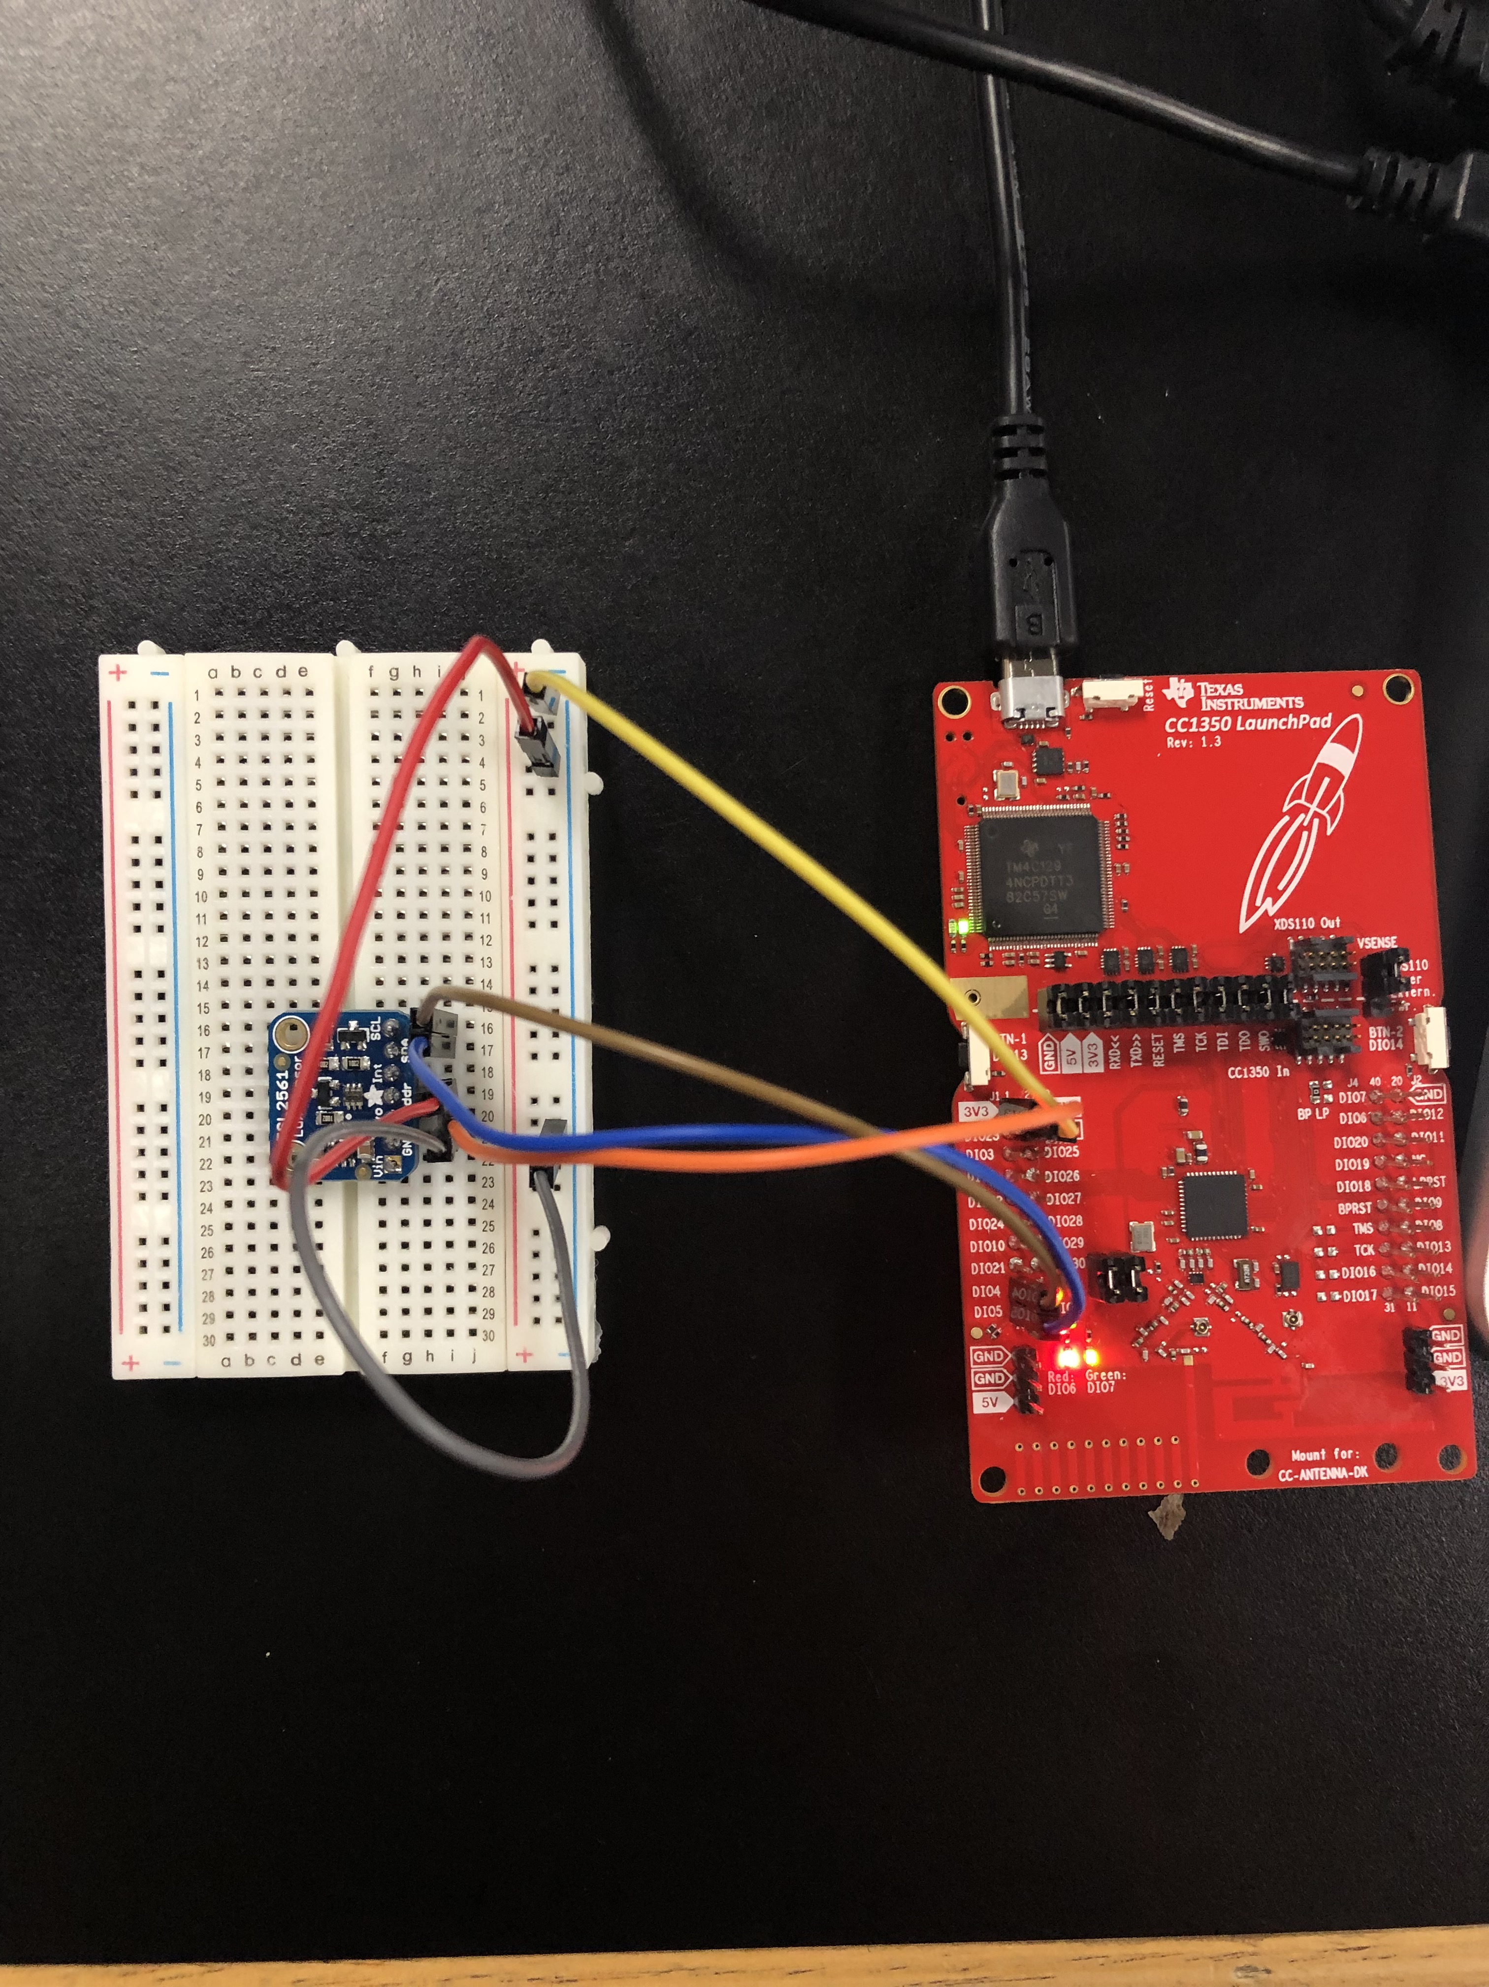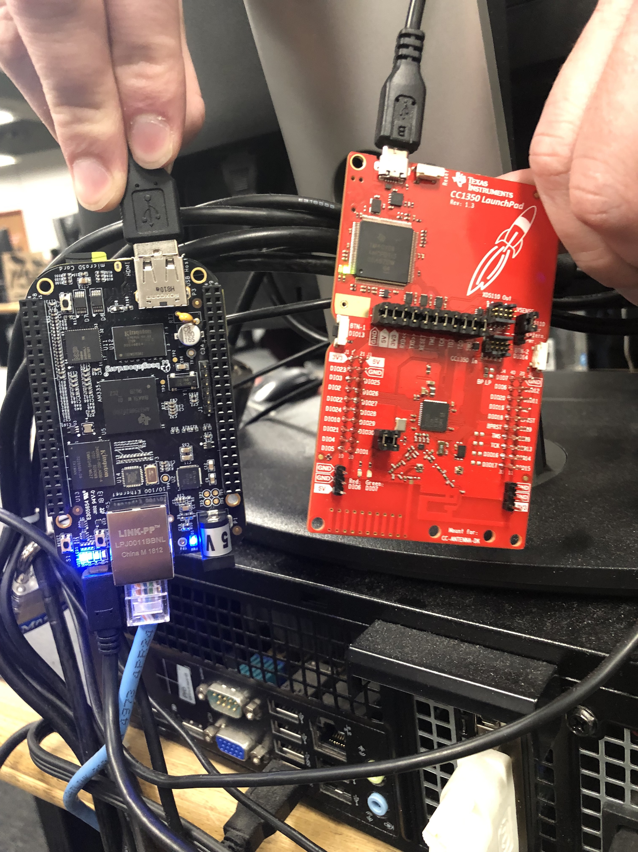

outcomes, results and conclusions:

|  |  |  |  |  |
| --- | --- | --- | --- | --- |
|  | Moderate Lighting  Room Temperature | Moderate Lighting  Warm Room | Bright Lighting  Room Temperature | Bright Lighting  Warm Room |
| Temperature (˚C) | 22 | 26 | 22 | 26 |
| Lux | 11 | 11 | 28 | 28 |

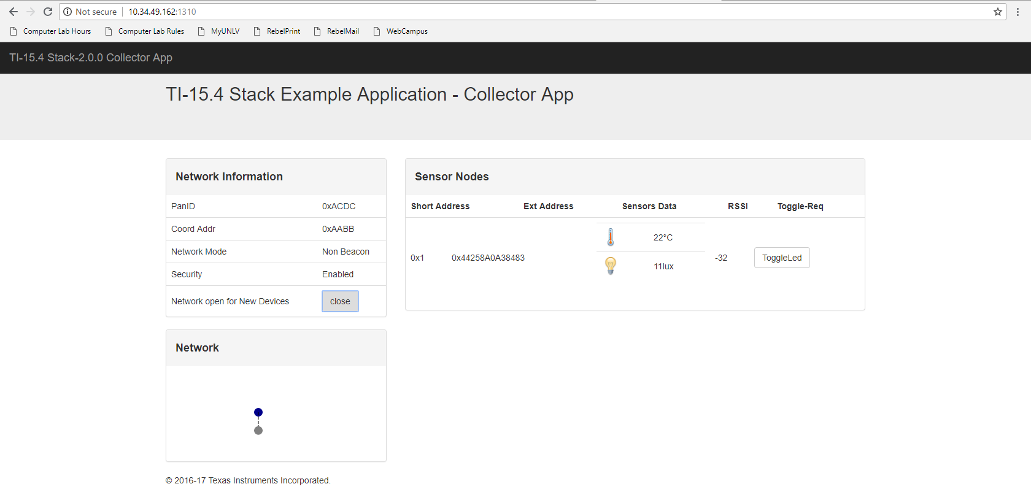

referenceS:

“Sub-1 GHz Sensor to Cloud IoT Gateway - Review.” *Recent Posts*, 12 Jan. 2018,

[www.element14.com/community/roadTestReviews/2590/l/sub-1-ghz-sensor-to-cloud-iot](http://www.element14.com/community/roadTestReviews/2590/l/sub-1-ghz-sensor-to-cloud-iot)

gateway-review.

“Adding New Sensor Support To Sub1GHz Sensor To Cloud Linux Gateway.” *MSP430*

*LaunchPad Tutorials - Texas Instruments Wiki*,

processors.wiki.ti.com/index.php/Adding_New_Sensor_Support_To_Sub1GHz_Sensor_To_Cloud_Linux_Gateway.

**VIDEO LINKS**:

Demo: <https://www.youtube.com/watch?v=HwtS9RuG0Ac&index=33&list=PLOWewY7_3-gMMc_-rHnzRPomB3qFueNhZ&t=0s>

Presentation: <https://www.youtube.com/watch?v=IcOxAoLsm2I&index=34&list=PLOWewY7_3-gMMc_-rHnzRPomB3qFueNhZ&t=2s>